Corporate Finance, (Berk/DeMarzo)
Chapter 26 Working Capital Management

26.1 Overview of Working Capital

Consider the following information for the question(s) below.

Hammond Motors had sales of $35 million in 2009 with a cost of goods sold of $20 million. A simplified balance sheet for Hammond appears below (amounts in $ million):

Assets |  |  | Liabilities and Equity
Cash | 1.6 |  | Accounts Payable | 1.8
Accounts Receivable | 4.2 |  | Notes Payable | 3.2
Inventory | 3 |  | Accruals | 1.5
Current Assets | 8.8 |  | Total Current Liabilities | 6.5
 |  |  | Long-term Debt | 4
Net Property, Plant and Equipment | 8.2 |  | Total Liabilities | 10.5
 |  |  | Stockholders' Equity | 6.5
Total Assets | 17 |  | Total Liabilities and Stockholders' Equity | 17

1) Hammond's net working capital in 2009 is closest to:
A) $2.3 million
B) $3.8 million
C) $6.5 million
D) $10.5 million
Answer: A
Explanation: A) NWC = CA - CL = 8,800 - 6,500 = 2,300 or $2.3 million
Diff: 1
Section: 26.1 Overview of Working Capital
Skill: Analytical

2) Hammond's cash conversion cycle in 2009 is closest to:
A) 22 days
B) 44 days
C) 58 days
D) 66 days
Answer: D
Explanation: D) CCC = accounts receivables days + inventory days - accounts payable days

Accounts Receivable Days = 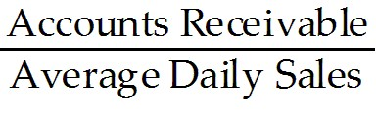 = 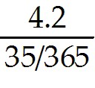 = 43.8 days
Inventory Days = 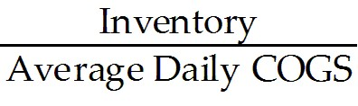 = 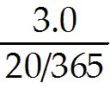 = 54.75 days
Accounts Payable Days = 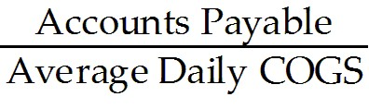 = 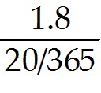 = 32.85 days

CCC = 43.8 days + 54.75 days - 32.85 days - 65.70 days
Diff: 2
Section: 26.1 Overview of Working Capital
Skill: Analytical
3) The difference between a firm's operating cycle and its cash cycle is:
A) there is no difference between the cash and operating cycles.
B) its account receivable days.
C) its accounts payable days.
D) its inventory days.
Answer: C
Diff: 1
Section: 26.1 Overview of Working Capital
Skill: Definition

4) The cash conversion cycle (CCC) is defined as:
A) Inventory Days + Accounts Receivable Days - Accounts Payable Days.
B) Inventory Days - Accounts Receivable Days - Accounts Payable Days.
C) Inventory Days + Accounts Receivable Days + Accounts Payable Days.
D) Inventory Days + Accounts Payable Days - Accounts Receivable Days.
Answer: A
Diff: 1
Section: 26.1 Overview of Working Capital
Skill: Definition

5) Which of the following statements is FALSE?
A) The main components of net working capital are cash, inventory, receivables, and payables.
B) The firm's cash cycle is the average length of time between when a firm originally purchases its inventory and when it receives the cash back from selling its product.
C) Working capital includes the cash that is needed to run the firm on a day-to-day basis. It does not include excess cash, which is cash that is not required to run the business and can be invested at a market rate.
D) If the firm pays cash for its inventory, the firm's operating cycle is identical to the firm's cash cycle.
Answer: B
Explanation: B) The firm’s operating cycle is the average length of time between when a firm originally purchases its inventory and when it receives the cash back from selling its product.
Diff: 2
Section: 26.1 Overview of Working Capital
Skill: Conceptual
6) Which of the following statements is FALSE?
A) A firm's cash cycle is the length of time between when the firm pays cash to purchase its initial inventory and when it receives cash from the sale of the output produced from that inventory.
B) The longer a firm's cash cycle, the more working capital it has, and the more cash it needs to carry to conduct its daily operations.
C) Most firms buy their inventory on credit, which increases the amount of time between the cash investment and the receipt of cash from that investment.
D) Any reduction in working capital requirements generates a positive free cash flow that the firm can distribute immediately to shareholders.
Answer: C
Explanation: C) Most firms buy their inventory on credit, which reduces the amount of time between the cash investment and the receipt of cash from that investment.
Diff: 2
Section: 26.1 Overview of Working Capital
Skill: Conceptual

Use the table for the question(s) below.

Luther Industries had sales of $980 million and a cost of goods sold of $560 million in 2006. A simplified balance sheet for the firm appears below:

Luther Industries
Balance Sheet
As of December 31, 2006
(millions of dollars)

Assets |  |  | Liabilities and Equity
Cash | 25 |  | Accounts payable | 60
Accounts receivable | 85 |  | Notes payable | 425
Inventory | 90 |  | Accruals | 45
Total current assets | 200 |  | Total current liabilities | 530
Net plant, property, and equipment | 6,100 |  | Long term debt | 2,725
Total assets | 6,300 |  | Total liabilities | 3,255
 |  |  | Common equity | 3,045
 |  |  | Total liabilities and equity | 6,300

7) Luther's Inventory days is closest to:
A) 32 days
B) 59 days
C) 39 days
D) 42 days
Answer: B
Explanation: B) Inventory days = 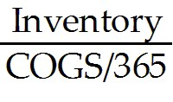 = 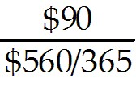 = 58.66 days
Diff: 1
Section: 26.1 Overview of Working Capital
Skill: Analytical
8) Luther's Accounts Receivable days is closest to:
A) 42 days
B) 39 days
C) 32 days
D) 59 days
Answer: C
Explanation: C) Accounts Receivable days = 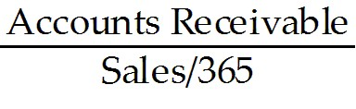 = 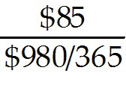 = 31.66 days
Diff: 1
Section: 26.1 Overview of Working Capital
Skill: Analytical

9) Luther's Accounts Payable days is closest to:
A) 39 days
B) 32 days
C) 59 days
D) 42 days
Answer: A
Explanation: A) Accounts Payables days = 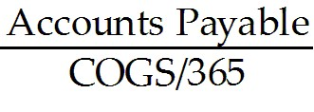 = 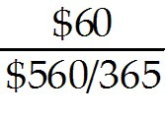 = 39.11 days
Diff: 1
Section: 26.1 Overview of Working Capital
Skill: Analytical

10) Luther's cash conversion cycle is closest to:
A) 51 days
B) 66 days
C) 71 days
D) 129 days
Answer: A
Explanation: A) Inventory days = = = 58.66 days
Accounts Receivable days = = = 31.66 days
Accounts Payables days = = = 39.11 days
CCC = Inventory days + Accounts Receivable days - Accounts Payable days
CCC = 58.66 + 31.66 - 39.11 = 51.21 days
Diff: 2
Section: 26.1 Overview of Working Capital
Skill: Analytical
11) Calculate the number of days in Luther's Operating Cycle.
Answer: Inventory days = = = 58.66 days
Accounts Receivable days = = = 31.66 days
Operating Cycle = Inventory days + accounts receivable days = 58.66 + 31.66 = 90.32 days
Diff: 2
Section: 26.1 Overview of Working Capital
Skill: Analytical

12) KT Enterprises would like to construct and operate a new ice skating rink. In addition to the capital expenditures on the rink, management estimates that the project will require an investment today of $220,000 in net working capital. The firm will recover the investment in net working capital fifteen years from today, when management anticipates closing the rink. The discount rate for this type of cash flow is 8% per year. Calculate the present value of the cost of working capital for the ice skating rink.
Answer: NPV = -$220,000 + 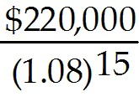 = -$150,646.82
Diff: 1
Section: 26.1 Overview of Working Capital
Skill: Analytical

26.2 Trade Credit

1) Collection float is made up of all of the following EXCEPT:
A) disbursement float.
B) processing float.
C) mail float.
D) availability float.
Answer: A
Diff: 1
Section: 26.2 Trade Credit
Skill: Conceptual

2) Which of the following statements is FALSE?
A) Under the Modigliani-Miller assumptions of perfect capital markets, the amounts of payables and receivables are irrelevant.
B) One factor that contributes to the length of a firm's receivables and payables is the delay between the time a bill is paid and the cash is actually received.
C) Collection float is the amount of time it takes before payments to suppliers actually result in a cash outflow for the firm.
D) The credit that the firm is extending to its customer is known as trade credit.
Answer: C
Explanation: C) Disbursement float is the amount of time it takes before payments to suppliers actually result in a cash outflow for the firm.
Diff: 2
Section: 26.2 Trade Credit
Skill: Conceptual
3) Which of the following statements is FALSE?
A) The Check Clearing for the 21st Century Act (Check 21), which became effective on October 28, 2004, eliminated the disbursement float due to the check-clearing process.
B) Trade credit is, in essence, a loan from the selling firm to its customer.
C) The accounts receivable balance represents the amount that a firm owes its suppliers for goods that it has received but for which it has not yet paid.
D) Providing financing at below-market rates is an indirect way to lower prices for only certain customers.
Answer: C
Explanation: C) The accounts payable balance represents the amount that a firm owes its suppliers for goods that it has received but for which it has not yet paid.
Diff: 2
Section: 26.2 Trade Credit
Skill: Conceptual

4) The term 2/10 net 30 means:
A) If the invoice is paid within 10 days a 2% discount can be taken. If the invoice is paid between 11 and 29 days a 1% discount can be taken. After 30 days the full invoice is due.
B) If the invoice is paid within 2 days a 10% discount can be taken, otherwise the full invoice is due in 30 days.
C) If the invoice is paid within 2 days a 10% discount can be taken, otherwise a 2% discount can be taken if the invoice is paid in 30 days.
D) If the invoice is paid within 10 days a 2% discount can be taken, otherwise the full invoice is due in 30 days.
Answer: D
Diff: 1
Section: 26.2 Trade Credit
Skill: Definition

5) Your firm purchases goods from its supplier on terms of 1/10, net 30. The effective annual cost to your firm if it chooses not to take advantage of the trade discount offered is closest to:
A) 16.8%
B) 44.6%
C) 20.1%
D) 13.0%
Answer: C
Explanation: C) The difference in days = 30 - 10 = 20 days. You will either pay $0.99 on a dollar of sales in 10 days or $1.00 on a dollar of sales in 30 days.

EAR = 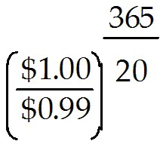- 1 = .201317 or 20.13%
Diff: 1
Section: 26.2 Trade Credit
Skill: Analytical
6) Your firm purchases goods from its supplier on terms of 2/10, net 45. Calculate the effective annual cost to your firm if it chooses not to take advantage of the trade discount offered.
Answer: The difference in days = 45 - 10 = 35 days. You will either pay $0.98 on a dollar of sales in 10 days or $1.00 on a dollar of sales in 45 days.

EAR = 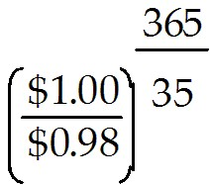- 1 = .234524 or 23.45%
Diff: 1
Section: 26.2 Trade Credit
Skill: Analytical
26.3 Receivables Management

Use the following information for the question(s) below.

Wyatt Oil has the following accounts on its books:
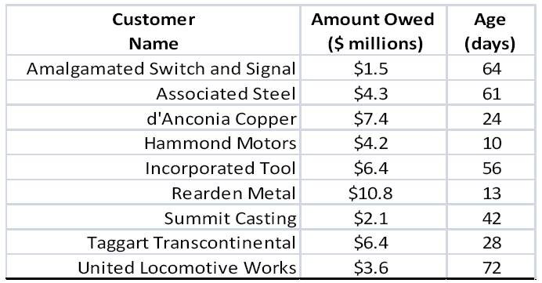

Rearden extends credit on terms of 1/15, net 30.

1) The percentage of Wyatt's receivables that are current is closest to:
A) 32.1%
B) 38.3%
C) 42.2%
D) 61.7%
Answer: D
Explanation: D)
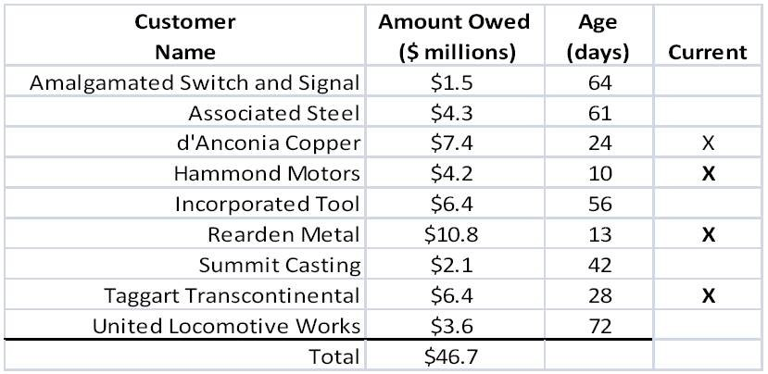

Percentage eligible = 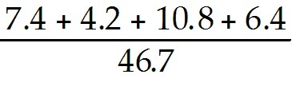 = 61.7%
Diff: 2
Section: 26.3 Receivables Management
Skill: Analytical
2) The percentage of Wyatt's receivables that are still eligible to take the discount is closest to:
A) 20.1%
B) 32.1%
C) 38.3%
D) 42.2%
Answer: B
Explanation: B)
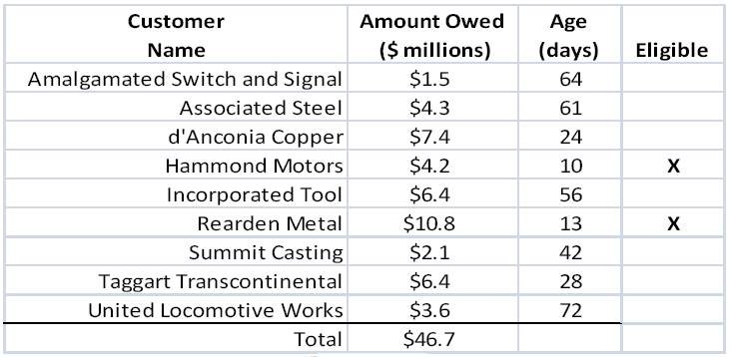

Percentage eligible = 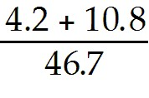 = 32.1%
Diff: 2
Section: 26.3 Receivables Management
Skill: Analytical

3) The percentage of Wyatt's receivables that are past due is closest to:
A) 20.1%
B) 32.1%
C) 38.3%
D) 42.2%
Answer: C
Explanation: C)
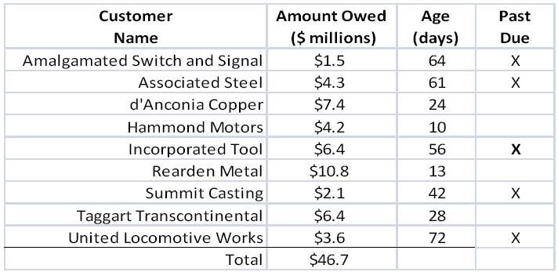

Percentage eligible = 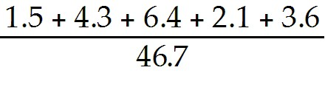 = 38.3%
Diff: 2
Section: 26.3 Receivables Management
Skill: Analytical
4) The percentage of Wyatt's receivables that are more than 30 days past due is closest to:
A) 20.1%
B) 32.1%
C) 38.3%
D) 42.2%
Answer: A
Explanation: A)
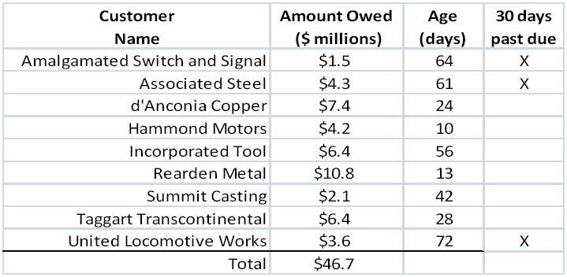

Percentage eligible = 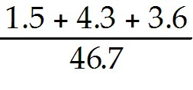 = 20.1%
Diff: 2
Section: 26.3 Receivables Management
Skill: Analytical

5) Which one of the following is NOT one of the three steps involved in establishing a credit policy?
A) Establishing credit payment patterns
B) Establishing credit standards
C) Establishing a collection policy
D) Establishing credit terms
Answer: A
Diff: 1
Section: 26.3 Receivables Management
Skill: Conceptual

6) Which of the following statements is FALSE?
A) After a firm decides on its credit standards, it must next establish its credit terms.
B) The decision of how much credit risk to assume plays a large role in determining how much money a firm ties up in its payables.
C) Knowledge of the payments pattern is also useful for forecasting the firm's working capital requirements.
D) An aging schedule categorizes accounts by the number of days they have been on the firm's books.
Answer: B
Explanation: B) The decision of how much credit risk to assume plays a large role in determining how much money a firm ties up in its receivables.
Diff: 2
Section: 26.3 Receivables Management
Skill: Conceptual
7) Which of the following statements is FALSE?
A) The aging schedule is also sometimes augmented by analysis of the payments pattern, which provides information on the percentage of monthly sales that the firm collects in each month after the sale.
B) Because accounts receivable days can be calculated from the firm’s financial statement, outside investors commonly use this measure to evaluate a firm’s credit management policy.
C) If the aging schedule gets "top-heavy"—that is, if the percentages in the upper half of the schedule begin to increase—the firm will likely need to revisit its credit policy.
D) Seasonal sales patterns may cause the number calculated for the accounts receivable days to change depending on when the calculation takes place.
Answer: C
Explanation: C) If the aging schedule gets "bottom-heavy"—that is, if the percentages in the lower half of the schedule begin to increase—the firm will likely need to revisit its credit policy.
Diff: 2
Section: 26.3 Receivables Management
Skill: Conceptual

8) Luther Industries bills its accounts on terms of 2/10, net 30. The firm's accounts receivable include $250,000 that has been outstanding for 10 or fewer days, $375,000 outstanding for 11 to 30 days, $70,000 outstanding for 31 to 40 days, $35,000 outstanding for 41 to 50 days, $20,000 outstanding for 51 to 60 days, and $8,000 outstanding for more than 60 days. Prepare an aging schedule for Luther Industries.
Answer:
Days Outstanding | Amount Outstanding ($) | Percentage Outstanding (%)
1 - 10 | $250,000 | 33.0%
11 - 30 | $375,000 | 49.5%
31 - 40 | $70,000 | 9.2%
41 - 50 | $35,000 | 4.6%
51 - 60 | $20,000 | 2.6%
60 + | $8,000 | 1.1%
Total = | $758,000
Diff: 2
Section: 26.3 Receivables Management
Skill: Analytical
26.4 Payables Management

1) Wyatt Oil purchases goods from its suppliers on terms 3/20 net 40. The effective annual cost to Wyatt if they do not take the discount and pay on day 40 is closest to:
A) 18%
B) 45%
C) 75%
D) 82%
Answer: C
Explanation: C) The interest rate per period is $3/$97 = .031. If the firm delays payment until the 40th day, it has use of the funds for 20 days beyond the discount period. There are 365/20 = 18.25 20 day periods in one year. Thus, the effective annual cost is
(1 + .031)18.25 - 1 = .746 or 74.6%
Diff: 1
Section: 26.4 Payables Management
Skill: Analytical

2) Wyatt Oil purchases goods from its suppliers on terms 3/20 net 40. The effective annual cost to Wyatt if they do not take the discount and pay on day 50 is closest to:
A) 18%
B) 45%
C) 75%
D) 82%
Answer: B
Explanation: B) The interest rate per period is $3/$97 = .031. If the firm delays payment until the 50th day, it has use of the funds for 30 days beyond the discount period. There are 365/30 = 12.167 30 day periods in one year. Thus, the effective annual cost is
(1 + .031)12.167 - 1 = .45 or 45.0%
Diff: 1
Section: 26.4 Payables Management
Skill: Analytical

3) Which of the following statements is FALSE?
A) The lower the discount percentage offered, the greater the cost of forgoing the discount and using trade credit.
B) A firm should choose to borrow using accounts payable only if trade credit is the cheapest source of funding.
C) A firm should always pay on the latest day allowed.
D) A firm should strive to keep its money working for it as long as possible without developing a bad relationship with its suppliers or engaging in unethical practices.
Answer: A
Explanation: A) The higher the discount percentage offered, the greater the cost of forgoing the discount and using trade credit.
Diff: 1
Section: 26.4 Payables Management
Skill: Conceptual
4) Which of the following statements is FALSE?
A) Similar to the situation with its accounts receivable, a firm should monitor its accounts payable to ensure that it is making its payments at an optimal time.
B) Some firms ignore the payment due period and pay later, in a practice referred to as pushing the accounts payable.
C) Suppliers may react to a firm whose payments are always late by imposing terms of cash on delivery (COD) or cash before delivery (CBD).
D) If the accounts payable outstanding is 40 days and the terms are 2/10, net 30, the firm can conclude that it generally pays late and may be risking supplier difficulties.
Answer: B
Explanation: B) Some firms ignore the payment due period and pay later, in a practice referred to as stretching the accounts payable.
Diff: 1
Section: 26.4 Payables Management
Skill: Conceptual

5) Your firm purchases goods from its supplier on terms of 1/10, net 30. The effective annual cost to your firm if it chooses not to take advantage of the trade discount offered and stretches the accounts payable to 45 days is closest to:
A) 13.0%
B) 11.1%
C) 15.9%
D) 20.1%
Answer: B
Explanation: B) The difference in days = 45 - 10 = 35 days. You will either pay $0.99 on a dollar of sales in 10 days or $1.00 on a dollar of sales in 30 days.

EAR = 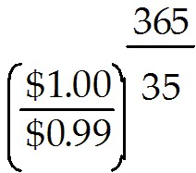- 1 = .110500 or 11.05%
Diff: 2
Section: 26.4 Payables Management
Skill: Analytical

6) Your firm purchases goods from its supplier on terms of 2/10, net 40. The effective annual cost to your firm if it chooses not to take advantage of the trade discount offered and stretches the accounts payable to 60 days is closest to:
A) 20.1%
B) 15.9%
C) 13.0%
D) 11.1%
Answer: B
Explanation: B) The difference in days = 60 - 10 = 50 days. You will either pay $0.98 on a dollar of sales in 10 days or $1.00 on a dollar of sales in 30 days.

EAR = 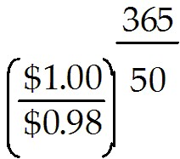- 1 = .11589 or 15.89%
Diff: 2
Section: 26.4 Payables Management
Skill: Analytical
7) Kinston Industries has an average accounts payable balance of $220,000. Its annual cost of goods sold is $5,475,000, and it receives terms of 2/10, net 30 from its suppliers. Kinston chooses to forgo this discount. Is Kinston managing its accounts payables well?
Answer: The firm is not managing its accounts payables well. Kinston's days payable outstanding is 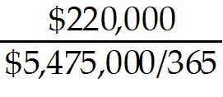 = 14.67 days. If Kinston made the payments less than five days earlier, they could take a 2% discount. If, for some reason, they choose to forgo the discount, then they should not be paying the full amount until 30 days.
Diff: 2
Section: 26.4 Payables Management
Skill: Analytical

8) Goldsboro Industries has an average accounts payable balance of $680,000. Its annual cost of goods sold is $4,500,000, and it receives terms of 1/10, net 40 from its suppliers. Goldsboro chooses to forgo this discount. Is Goldsboro managing its accounts payables well?
Answer: The firm is not managing its accounts payables well. Goldsboro's days payable outstanding is 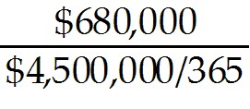 = 55.16 days. They are over the term of 40 days offer by their suppliers. Goldsboro is stretching the terms of the credit agreement and risks having problems with their suppliers as a result.
Diff: 2
Section: 26.4 Payables Management
Skill: Analytical

26.5 Inventory Management

Use the following information to answer the question(s) below:

Rearden Metal (RM) had $120 million in sales in 2009. Its cost of goods sold was $85, and its average inventory balance was $15 million.

1) 1. The average number of inventory days outstanding for Rearden is closest to:
A) 6 days
B) 8 days
C) 37 days
D) 64 days
Answer: D
Explanation: D) Days in Inventory = 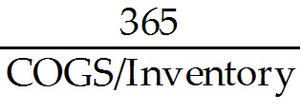 = 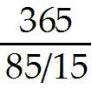 = 64.412 days
Diff: 1
Section: 26.5 Inventory Management
Skill: Analytical
2) The industry average days of inventory is 75 days. The amount that Rearden would have to increase/decrease its inventory in order to match the industry average is closest to:
A) decrease inventory by 2.2 million
B) increase inventory by 2.2 million
C) increase inventory by 2.5 million
D) increase inventory by 4.2 million
Answer: C
Explanation: C) Current Days in Inventory = = 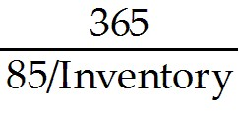 = 75 days
Solving for inventory:
Inventory = 75 days × 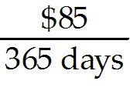 = 17.466,
this translates into an increase in inventory of 17.466 - 15 = 2.466
Diff: 2
Section: 26.5 Inventory Management
Skill: Analytical

3) Which of the following is NOT a direct cost associated with inventory?
A) Acquisition costs
B) Order costs
C) Carrying costs
D) Stock out costs
Answer: D
Diff: 1
Section: 26.5 Inventory Management
Skill: Definition

4) Which of the following statements is FALSE?
A) Under the Modigliani-Miller assumptions of perfect capital markets, the amount of inventory is irrelevant.
B) Unlike trade credit, inventory represents one of the required factors of production.
C) It is the firm’s financial manager who must arrange for the financing necessary to support the firm's inventory policy and who is responsible for ensuring the firm’s overall profitability.
D) Inventory management receives extensive coverage in courses on operations management.
Answer: A
Explanation: A) Even in a perfect markets setting in which the Modigliani-Miller propositions hold, firms still need inventory.
Diff: 2
Section: 26.5 Inventory Management
Skill: Conceptual
5) Which of the following statements is FALSE?
A) Firms may hold inventory because factors such as seasonality in demand mean that customer purchases do not perfectly match the most efficient production cycle.
B) Inventory helps minimize the risk that the firm will not be able to obtain an input it needs for production.
C) If a firm holds too much inventory, stock-outs, the situation when a firm runs out of product, may occur, leading to lost sales.
D) Because excessive inventory uses cash, efficient management of inventory increases firm value.
Answer: C
Explanation: C) If a firm holds too little inventory, stock-outs, the situation when a firm runs out of product, may occur, leading to lost sales.
Diff: 2
Section: 26.5 Inventory Management
Skill: Conceptual

6) Describe "just-in-time" inventory management.
Answer: Some firms seek to reduce their carrying costs as much as possible. With "just-in time" (JIT) inventory management, a firm acquires inventory precisely when needed so that its inventory balance is always zero, or very close to it. This technique requires exceptional coordination with suppliers as well as a predictable demand for the firm's products. In addition, there may be a trickle-down effect when one firm in an industry adopts JIT. For example, in 1999, Toys 'R Us instituted JIT, which caused one of its suppliers, toy manufacturer Hasbro, to make changes in its production schedule.
Diff: 2
Section: 26.5 Inventory Management
Skill: Conceptual

26.6 Cash Management

1) Which of the following money market investments is a short-term debt obligations of the U.S. government?
A) Treasury Bill
B) Repurchase Agreement
C) Commercial Paper
D) Certificates of Deposit (CD)
E) Banker’s Acceptance
Answer: A
Diff: 1
Section: 26.6 Cash Management
Skill: Definition
2) Which of the following money market investments is short-term debt issued by a bank with a minimum denomination of $100,000?
A) Treasury Bill
B) Banker’s Acceptance
C) Repurchase Agreement
D) Commercial Paper
E) Certificates of Deposit (CD)
Answer: E
Diff: 1
Section: 26.6 Cash Management
Skill: Definition

3) Which of the following money market investments is essentially a loan arrangement wherein a securities dealer is the "borrower" and the investor is the "lender." The investor buys securities from the securities dealer, with an agreement to sell the securities back to the dealer at a later date for a specified higher price?
A) Certificates of Deposit (CD)
B) Commercial Paper
C) Banker's Acceptance
D) Repurchase Agreement
E) Treasury Bill
Answer: D
Diff: 1
Section: 26.6 Cash Management
Skill: Definition

4) Which of the following money market investments is a draft written by the borrower and guaranteed by the bank on which the draft is drawn. Typically used in international trade transactions. The borrower is an importer who writes the draft in payment for goods?
A) Treasury Bill
B) Repurchase Agreement
C) Certificates of Deposit (CD)
D) Banker's Acceptance
E) Commercial Paper
Answer: D
Diff: 1
Section: 26.6 Cash Management
Skill: Definition

5) Which of the following money market investments is a short-term, unsecured debt obligation issued by a large corporation. The minimum denomination is $25,000, but most have a face value of $100,000 or more?
A) Banker's Acceptance
B) Commercial Paper
C) Repurchase Agreement
D) Certificates of Deposit (CD)
E) Treasury Bill
Answer: B
Diff: 1
Section: 26.6 Cash Management
Skill: Definition
6) The amount of cash a firm needs to be able to pay its bills is sometimes referred to as a(n):
A) operating balance.
B) compensating balance.
C) transactions balance.
D) precautionary balance.
Answer: C
Diff: 1
Section: 26.6 Cash Management
Skill: Definition

7) The amount of cash a firm holds to counter the uncertainty surrounding its future cash needs is known as a(n):
A) speculative balance.
B) compensating balance.
C) operating balance.
D) precautionary balance.
Answer: D
Diff: 1
Section: 26.6 Cash Management
Skill: Definition

8) What is a compensating balance?
Answer: A firm's bank may require it to hold a compensating balance in an account at the bank as compensation for services that the bank performs. Compensating balances are typically deposited in accounts that either earn no interest or pay a very low interest rate. This arrangement is similar to a bank offering individuals free checking so long as their balances do not fall below a certain level–say, $1000. Essentially, the customer has $1000 cash that he cannot use unless he is willing to pay a service charge. Similarly, the cash that a firm has tied up to meet a compensating balance requirement is unavailable for other uses.
Diff: 2
Section: 26.6 Cash Management
Skill: Conceptual

